User Manual

1. Click on this link https://car-price-price.herokuapp.com/ to open the Web App to detect hate speech in tweets.
2. Startup page will display as below.

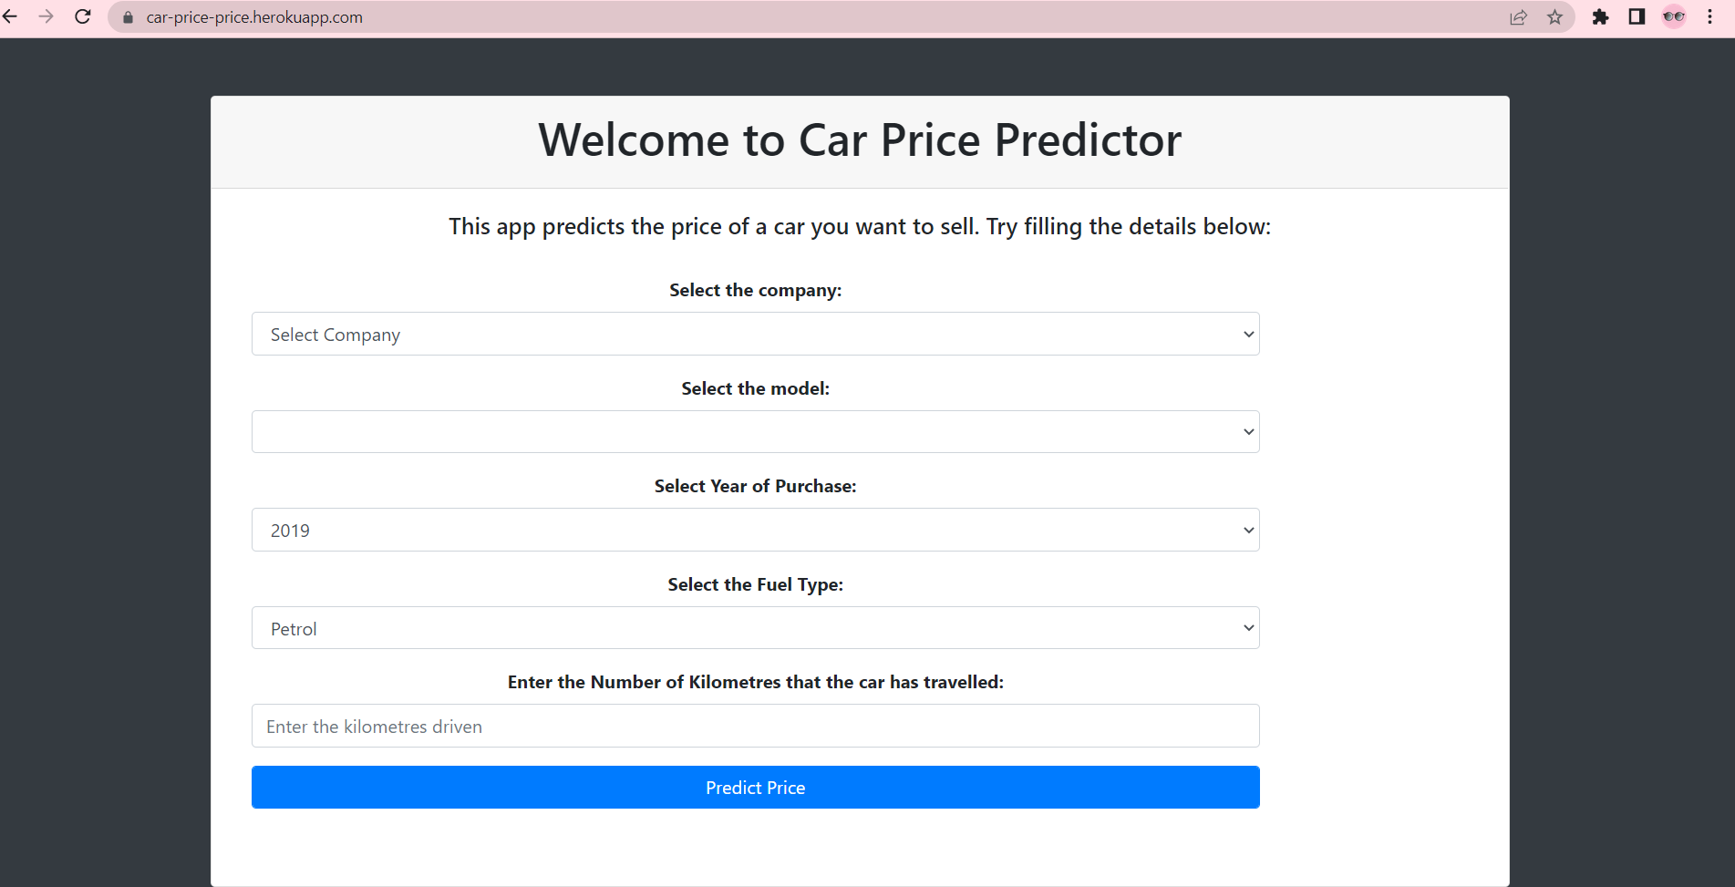

1. Enter a tweet to be analyzed.

